CSE 581

**Lab 8: Data Manipulation**

**Purpose:**

Work with tables – Fill the tables with data, extract the data.

**Deliverables:**

Multiple screenshots, as described through the lab.

Scripts that you used to carry out the actions.

**Steps:**

1. Insert the following data into the tables you created last lab in database CSE581labs. Make sure that the data matches perfectly.

*For each table* provide a **screenshot** of script execution as well as a **screenshot** of running a select against the table, displaying its data.

***USERS:***

|  |  |  |  |  |  |
| --- | --- | --- | --- | --- | --- |
| **NTID** | **FirstName** | **MiddleI** | **LastName** | **EmailAddress** | **Password** |
| 01-HJPotter | Harry | J | Potter | [hp@hw.edu](mailto:hp@syu.edu) | Hedwig |
| 02-RBWeasley | Ron | B | Weasley | [rw@hw.edu](mailto:rw@syu.edu) | Scabbers |
| 03-HJGranger | Hermione | J | Granger | [hg@hw.edu](mailto:hg@syu.edu) | Crookshanks |
| 10-Rlupin | Remus | <NULL> | Lupin | [rl@hw.edu](mailto:rl@syu.edu) | moon |
| 11-Fflitwick | Filius | <NULL> | Flitwick | [ff@hw.edu](mailto:ff@hg.edu) | <NULL> |
| 16-Rhagrid | Rubeus | <NULL> | Hagrid | [rh@hw.edu](mailto:rh@syu.edu) | BuckBeak |

***COURSES:***

|  |  |  |  |  |
| --- | --- | --- | --- | --- |
| **CourseID** | **CourseCode** | **CourseTitle** | **Faculty** | **OpenSeats** |
| 1 | DADA101 | Defence Against the Dark Arts BASIC | 10-Rlupin | 3 |
| 2 | DADA201 | Defence Against the Dark Arts INTERMEDIATE | 10-Rlupin | 2 |
| 3 | DADA301 | Defence Against the Dark Arts ADVANCED | 10-Rlupin | 1 |
| 4 | CHMS101 | Charms BASIC | 11-Fflitwick | 2 |
| 5 | CHMS201 | Charms INTERMEDIATE | 11-Fflitwick | 0 |
| 6 | CHMS301 | Charms ADVANCED | 11-Fflitwick | 4 |
| 7 | HOM101 | History of Magic BASIC | <NULL> | 10 |

***LETTER GRADES:***

|  |  |  |
| --- | --- | --- |
| **LetterGradeID** | **LetterGrade** | **Description** |
| 1 | O | Outstanding |
| 2 | E | Exceeds Expectations |
| 3 | A | Acceptable |
| 4 | P | Poor |
| 5 | D | Dreadful |
| 6 | T | Troll |

***COURSE GRADING:***

|  |  |  |  |
| --- | --- | --- | --- |
| **GradingScaleID** | **LetterGradeID** | **CourseID** | **GradeValue** |
| 1 | 1 | 1 | 95 |
| 2 | 2 | 1 | 90 |
| 3 | 3 | 1 | 80 |
| 4 | 4 | 1 | 70 |
| 5 | 5 | 1 | 60 |
| 6 | 6 | 1 | 0 |
| 7 | 1 | 2 | 100 |
| 8 | 2 | 2 | 90 |
| 9 | 3 | 2 | 85 |
| 10 | 4 | 2 | 75 |
| 11 | 5 | 2 | 64 |
| 12 | 6 | 2 | 0 |

***COURSE ENROLLMENT:***

|  |  |  |  |
| --- | --- | --- | --- |
| **EnrollmentID** | **StudentId** | **CourseID** | **FinalGrade** |
| 1 | 01-HJPotter | 1 | <NULL> |
| 2 | 01-HJPotter | 4 | <NULL> |
| 3 | 03-HJGranger | 1 | <NULL> |
| 4 | 03-HJGranger | 4 | <NULL> |
| 5 | 02-RBWeasley | 1 | <NULL> |
| 6 | 02-RBWeasley | 4 | <NULL> |
|  |  |  |  |

***NEXT PAGE***

1. Make the following updates (use UPDATE and DELETE, as needed):

*For each data modification* provide a **screenshot** of script execution. When all of the changes were done, also provide a **screenshot** of all tables, displaying the new data.

1. Lupin has been fired. Assign his classes to Hagrid. Remove Lupin from the database.

1. Harry has received a final grade of 96 in Defence Against the Dark Arts, and 91 in Charms.

1. Ron has received a final grade of 91 in Defence Against the Dark Arts, and 88 in Charms.

1. Hermione has received a final grade of 92 in Defence Against the Dark Arts, and 99 in Charms.

1. Enroll Harry in Intermediate Defence Against the Dark Arts.
2. Enroll Hermione in Advanced Charms.

For both questions, screenshot below

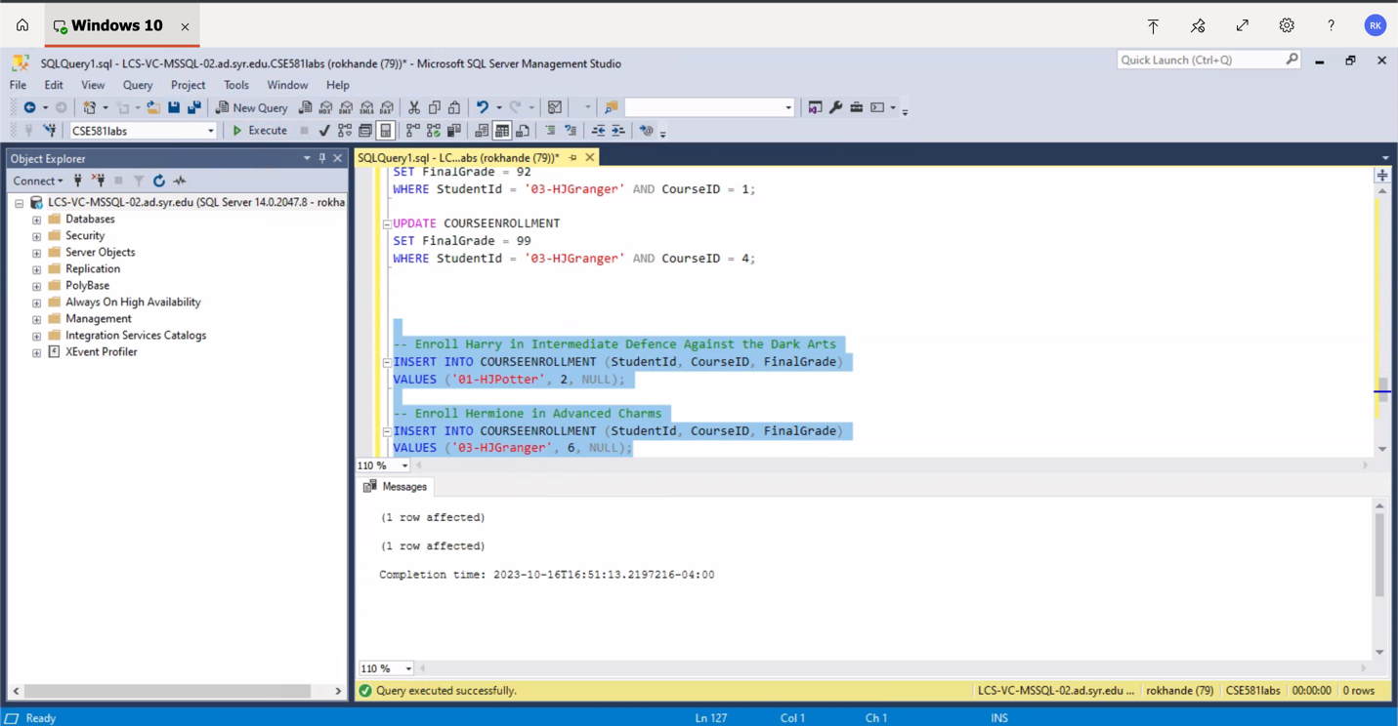

TABLES AFTER UPDATE QUERIES.

